Modern Slavery Supplier
Assessment and Risk Management

1.0 Purpose

2.0 Scope

3.0 Procedure

3.1 Process Overview | 3.2 Grievance Investigations

4.0 Definitions

5.0 Information

6.0 Related policy documents and supporting documents

1.0 Purpose
Griffith University is committed to continuous improvement in relation to our systems and controls to assess, mitigate and address modern slavery risks. As part of this commitment, the University has developed a specific procedure to support modern slavery risk assessment and management across our operations and supply chains. The procedure is an expression of the Griffith Supplier Code of Conduct and is consistent with the core conventions of the International Labour Organization, the United Nations Guiding Principles on Business and Human Rights and the Queensland Government’s commitment to eliminating modern slavery in government supply chains.
The purpose of this Griffith Modern Slavery Supplier Assessment and Management Procedure is to support stakeholders involved in sourcing events and contract management to take a risk-based approach to identifying, assessing, and working with suppliers to respond to the risk of harm to people across our supply chains. This process applies to Griffith’s Tier 1 suppliers (these are Griffith’s direct suppliers of goods/services). In future, this may extend to other tiers within our supply chain.
This Procedure should be used in conjunction with the Informed 365 Platform, a cloud-based solution chosen by Griffith to assess and engage with suppliers, prioritise tasks, track and report on progress.
Recognising that modern slavery is a global, evolving issue affecting all sectors and industries, this Procedure will be reviewed annually and updated in alignment with Griffith’s commitment to continuous improvement.

2.0 Scope
This procedure applies to all staff involved in sourcing events and contract management activities on behalf of Griffith.

3.0 Procedure

3.1 Process overview
As illustrated in figure 1 below, this 3-step process aligns and intersects with Griffith’s guidelines for:
- Below $450,000 (exc. GST) and Very Low to Medium Risk Sourcing, noting that this process only applies for sourcing activities with a total cost equal to or greater than $20,000 and a high-risk rating.
- Strategic Sourcing - sourcing activities with a total cost equal to or greater than $450,000 (excluding GST) irrespective of risk rating.
- Contract Management.
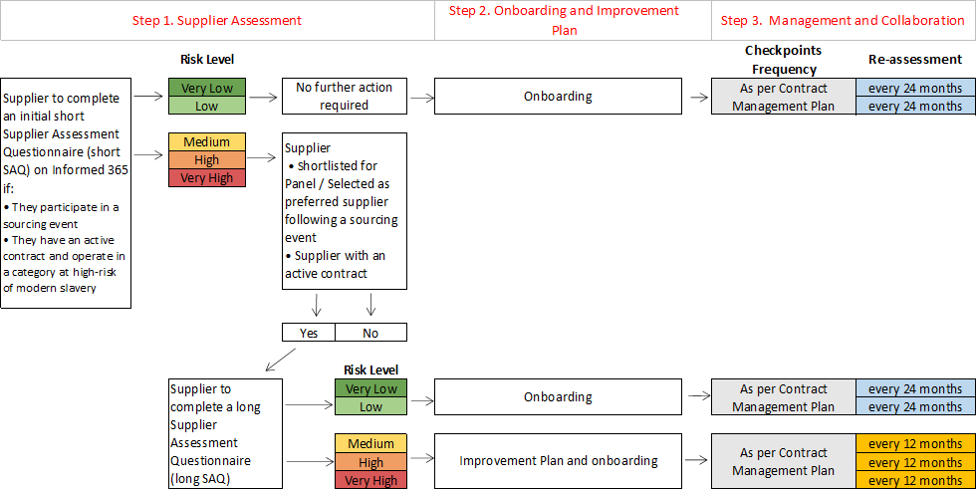
Figure 1 – Modern Slavery Risk Assessment and Management Overview

3.1.1 Step 1: Supplier Assessment

3.1.1.1 Short Supplier Assessment Questionnaire (Short SAQ)
As part of the sourcing process, suppliers, including vendors, service providers, and contractors, may be invited to submit an Expression of Interest (EOI) or an offer in response to a Request for Quotation (RFQ), Request for Proposal (RFP) or Invitation to Offer (ITO). In all these instances, the stakeholder responsible for the sourcing event, should ask suppliers to complete an initial modern slavery Supplier Assessment Questionnaire (Short SAQ). Within the same Short SAQ, suppliers are required to agree to comply with Griffith's Supplier Code of Conduct.
NOTES:
- The link to the Short SAQ is included in the Request for Quotation Part B Supplier Response Schedule - General Goods and Services.
- Suppliers who are already registered on the Informed 365 Platform and have been assessed within the last 12 months, will not be required to complete the Short SAQ.
- To gain access and receive training on the Platform, contact procurement@griffith.edu.au

As part of the contract management process, suppliers with an existing contract may also be invited to complete the Short SAQ on the Informed 365 Platform if they fall in a spend category at high risk of modern slavery, namely:
- Building & grounds.
- Construction refurbishment & works.
- Property Management.
- IT hardware and audiovisual.
- Laboratory and research.
- Travel and entertainment.
- Office related supply and services.
Upon completion of the Short SAQ, the Informed 365 Platform will automatically generate the risk rating, and specific actions should be taken according to the identified risk level:
RISK LEVEL | RATING
VERY LOW | Exceeds requirements
LOW | Meets requirements
MEDIUM | Meets requirements except for minor aspects
HIGH | Does not meet requirements but may be adaptable
VERY HIGH | Major non-compliance with requirements
Table 1. Supplier Risk Rating

3.1.1.2 Long Supplier Assessment Questionnaire (Long SAQ)
Suppliers with a very high, high or medium risk rating to the Short SAQ will be requested to complete a more extensive SAQ (Long SAQ), if they are:
  - Shortlisted for inclusion as a Panel member (usually EOI); or
  - Selected as preferred suppliers following a sourcing event (ITO, RFQ, RFP); or
  - Existing suppliers operating in a high-risk spend category.
Depending on the activity, either the Sourcing Lead or the Contract Manager will send the Long SAQ to suppliers through the Informed 365 Platform, and a second risk rating will be automatically generated for each supplier upon completion.
NOTES:
- Completion of the Long SAQ’s by suppliers may not always be timely or satisfactory, however, it is a requirement for supplying to Griffith. To encourage completion, it is crucial that Griffith communicates its expectations and the importance of suppliers’ meaningful responses. Griffith may also need to prompt and support the supplier to provide the information required to determine an appropriate modern slavery risk rating.
Suppliers with a very low or low risk rating to the Short SAQ will not be required to complete the Long SAQ and can move on to the onboarding process.

3.1.2 Step 2: Supplier Onboarding and Improvement Plan
Once the assessment process is finalized and regardless of the assigned risk level, the Sourcing Lead or Contract Manager should engage with suppliers to ensure that:
- The supplier agrees with the modern slavery provisions included in the relevant contract. The modern slavery provisions to be included in the contract are available on the Purchasing Page.
- Where applicable, the supplier agrees with implementing the time-bound Improvement Plan outlined on the Informed 365 Platform (see Step 3 for more details).

3.1.3 Step 3: Management and Collaboration
Suppliers with a Very Low or Low risk rating to the Long SAQ are not required to have an Improvement Plan.
However, suppliers with a Very High, High, or Medium risk rating to the Long SAQ will be asked to agree on an Improvement Plan to minimise the risks identified and encourage continuous improvement in their approach to addressing modern slavery.
Suppliers may receive multiple recommendations, but they're not required to act on all. We ask for the implementation of at least one recommendation within a suitable timeframe. While one action is the minimum, considering more is encouraged, except for non-negotiable actions posing a high harm risk to people. Contact Strategic Procurement and Supply for guidance if needed.
Actions expected from Sourcing Lead and/or Contract Managers:
- The Improvement Plan will be shared through the Informed 365 Platform. Suppliers will review the proposed Improvement Plan, commit to at least one recommended action that is relevant and feasible, prioritise all non-negotiable actions, and indicate a specific time frame for completing the selected actions.
- Commencing or continuing to provide goods and services to Griffith may not be appropriate until the actions outlined in the Improvement Plan are completed. Strategic Procurement and Supply can advise on the best course of action, taking into account that suppliers may be at various stages of maturity in their efforts to combat modern slavery. The approach should be collaborative, based on open communication, and focused on promoting ongoing improvement.
- If a supplier indicates they have no appetite to amend or enhance their modern slavery approach, or Griffith and the supplier cannot reach an agreement, the Sourcing Lead and/or Contract manager (as appropriate) should seek more information from the supplier to determine their reason for not wishing to collaborate.
- Sourcing Lead and/or Contract manager (as appropriate) should emphasise that Griffith recognises that this can take time and may require Griffith to assist the supplier.
Griffith recognises that modern slavery risk management is a process of continuous improvement and not a moment-in-time proposition. Once the Improvement Plan has been agreed, the Contract Manager is responsible for engaging and monitoring suppliers’ progress at a frequency that aligns with each supplier’s Contract Management Plan. The objective of having periodic checkpoints is to discuss progress on the improvement plan, collaborate on challenges and solutions and share Griffith’s and the Government’s expectations relating to modern slavery, for example by:
- Sharing Griffith’s annual Modern Slavery Statement.
- Sharing Griffith’s policy commitments and any updates.
- Sharing Griffith-developed or other guidance related to modern slavery risk management.
- Notifying suppliers of capability building sessions and/or practical tools to help suppliers manage the risk of modern slavery within their operations and supply chains.
- Referring to the Government’s guidelines (e.g., Eliminating modern slavery in government supply chains) and resources available here.
Suppliers will also be required to re-assess their approach to modern slavery on a regular basis, by completing a new Short or Long SAQ depending on their risk rating.
Details of the frequency of re-assessment required are also included in table 2 below.
RISK RATING | FREQUENCY OF CHECKPOINTS AND ASSOCIATED ACTIONS | FREQUENCY OF RE-ASSESSMENT
VERY HIGH | As per Contract Management Plan | Suppliers re-complete a Long SAQ every 12 months or as needed
HIGH | As per Contract Management Plan | Suppliers re-complete a Long SAQ every 12 months or as needed
MEDIUM | As per Contract Management Plan | Suppliers re-complete a Long SAQ every 12 months or as needed
LOW | As per Contract Management Plan | Suppliers re-complete a Short SAQ every 24 months or as needed
VERY LOW | As per Contract Management Plan | Suppliers re-complete a Short SAQ every 24 months or as needed
Table 2. Monitor and engagement frequency
As-needed, re-assessments outside of this regular cycle may also be triggered if:
- There is a change to the nature of the goods and services the supplier provides, or to the nature of the supplier’s operations and supply chain management.
- A supplier indicates they cannot complete/fulfil a commitment in their Improvement Plan.
- New or additional modern slavery risks are identified.
- Contract negotiations or variations are underway.
- An incident of modern slavery is identified, or a credible allegation of modern slavery practices or behaviours is detected during ongoing monitoring of other sources including notification by the supplier, via media sources or whistle blower reports.

3.2 Grievance Investigations
Substantiated allegations or findings of harm (e.g., through media exposure) would trigger a re-assessment of the supplier’s modern slavery risk rating and subsequent engagement and monitoring activities. All grievance investigations should be escalated to Strategic Procurement and Supply. For more information, please refer to Griffith’s Modern Slavery Grievance and Remediation Procedure.
Prospective supplier: If a modern slavery incident relating to a prospective supplier comes to the attention of Griffith, the stakeholder responsible for the sourcing event should liaise with Strategic Procurement and Supply to determine the correct course of action. A determination will then be made as to whether the supplier should still be eligible to supply to Griffith (subject to appropriate remediation actions and commitment to an Improvement Plan) or excluded from the sourcing event.
Existing supplier: Where the supplier has progressed through to onboarding, or if they are an existing supplier to Griffith, a re-assessment of the supplier may be required.

4.0 Definitions
Inherent Risk: refers to the level of risk within a particular business, industry, or supply chain for the potential occurrence or involvement in modern slavery practices. It signifies the underlying or built-in risk factors that are present due to various factors such as geographical location, industry type, labour practices, or specific vulnerabilities in the supply chain. These risk factors persist even if preventive measures are taken.
Modern slavery: Situations where coercion, threats or deception are used to exploit victims and undermine or deprive them of their freedom. Modern slavery, as an umbrella term covering numerous practices, is not defined under international law. For the purpose of this document, modern slavery is considered to include trafficking in persons, slavery, servitude, forced marriage, forced labour, debt bondage, deceptive recruiting for labour or services, and the worst forms of child labour.
Modern Slavery Risk: the potential for the supplier or a related entity to have adverse impacts on the protection or enjoyment of human rights by affected stakeholders, including the potential for modern slavery practices or behaviours to occur within the supply chain.
Modern Slavery Task Force: cross-functional, executive-level unit, established to provide strategic guidance for anti-slavery activities.
Residual risk: Residual risk represents the level of risk present once risk controls have been put in place, which should reduce the inherent risk but may not remove the risk entirely.
Supplier Assessment Questionnaire (SAQ): It is a set of questions to enable suppliers/vendors to share information about their business. The assessment process comprises of two types of SAQ, the Short SAQ and Long SAQ.
Short SAQ: It is designed to be quick and easy to complete, consisting of a limited number of questions to quickly assess the actions taken by the supplier to address modern slavery risks.
Long SAQ: It is extensive and comprehensive, with a wide range of questions that delve deeply into various aspects of a supplier's operations and practice. Its purpose is to facilitate an understanding of the residual risks, seeking detailed information regarding a supplier's policies, procedures, due diligence efforts, and actions taken to prevent and address modern slavery.
Supplier: A party in the supply chain that makes goods and services available to companies or consumers.
Tier-1 supplier: These are Griffith’s direct suppliers of the final product.
Tier-2 supplier: These are suppliers or subcontractors for Griffith’s tier 1 suppliers.

5.0 Information
Title | Modern Slavery Supplier Assessment and Risk Management Procedure.
Document number | 2023/0001212
Purpose | A specific procedure to support modern slavery risk assessment and management across our operations and supply chains.
Audience | Staff
Category | Operational
Subcategory | Finance
UN Sustainable Development Goals (SDs) | This document aligns with Sustainable Development Goal/s:  8: Decent Work and Economic Growth
Approval date | 26 October 2023
Effective date | 26 October 2023
Review date | 2024 (Currently under review)
Policy advisor | Head of Strategic Procurement and Supply
Approving authority | Chief Financial Officer

6.0 Related Policy Documents and Supporting Documents
Legislation | Modern Slavery Act 2018
Policy | Modern Slavery Policy  Procurement and Supply Policy  Supplier Code of Conduct
Procedures | Griffith’s Modern Slavery Grievance and Remediation Procedure
Local Protocol | N/A
Forms | N/A

