Legislative Compliance

1.0 Purpose

2.0 Scope

3.0 Policy statement

4.0 Roles, responsibilities and delegations

5.0 Definitions

6.0 Information

7.0 Related policy documents and supporting documents

1.0 Purpose

This policy states the commitment of Griffith University to meeting its legislative compliance obligations, including by implementing and maintaining a comprehensive enterprise-wide program designed to provide assurance to University Council, management, regulators, staff, students, and the broader community that compliance is fundamentally important to the University and that it takes steps to prevent, detect and respond to compliance breaches.

It recognises the responsibility of Griffith University to ensure that its strategic direction and its operations are pursued and conducted in a lawful manner, consistent with the values and ethical principles expressed in Griffith University’s Code of Conduct.

2.0 Scope
This policy applies to all areas of the University’s operations, including its staff, appointees of the University, its controlled entities, and to all activities authorised and conducted by or on behalf of the University.

3.0 Policy statement
It is vital for Griffith University that it earns, and continues to earn, the trust of the community and its representatives. The University’s standing and sustainability as a values-led, publicly funded institution for education and scientific endeavour depends on this.
To this end, the University will take a proactive and disciplined approach to legislative compliance management based on the following principles:
- An ethical culture within the University is fundamentally important, and leadership at all levels are expected to promote, foster, and support compliance.
- Compliance should not be “check the box”. We will aim to understand and communicate compliance in terms of what legislation seeks to achieve to ensure that the University achieves the substance, and not just the form, of compliance with its obligations.
- Compliance will be managed through comprehensive risk identification, assessment, review and reporting in accordance with the University’s risk management framework, the University’s risk appetite, and the three lines risk management model.
- Responsibility for managing compliance risks at Griffith University must be clearly defined.
- Compliance obligations for the University must be identified and kept up to date with changes in laws and the University’s operations. Processes to identify, record and communicate the University’s legislative compliance obligations to staff will be continually reviewed to continually improve the awareness of staff about what the University needs to comply with.
- Reporting of issues and incidents relating to legislative compliance, including breaches, is encouraged and all staff should feel comfortable and supported to raise and escalate concerns. This is essential for the University to take action to make necessary improvements.

3.1 Compliance Management Program
This Program is detailed in the Legislative Compliance Procedures, which will address:
- how compliance obligations are identified, kept up to date, and communicated to staff
- how responsibility for managing compliance risks are defined
- how compliance risks should be assessed, recorded and reviewed
- reporting protocols for compliance risks
- how staff should report compliance breaches.
The Program will:
- be designed to prevent, detect and respond to compliance risks and breaches
- integrate with the University Enterprise Risk Management Framework
- be informed by standards of best practice including ISO37301 Compliance Management Systems
- be subject to regular review to drive continual improvement.

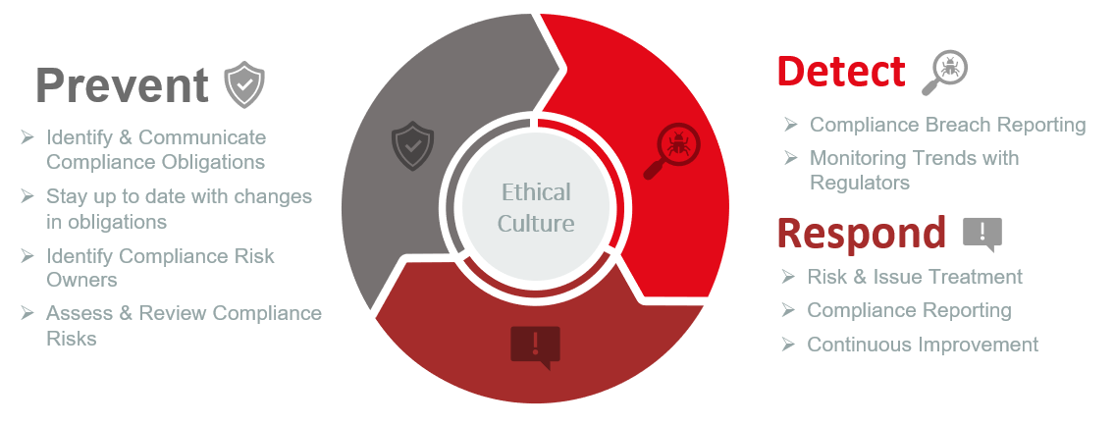

3.2 Reporting of Compliance Breaches
Legislative compliance breaches must be reported to General Counsel in accordance with the Compliance Procedures. Reporting breaches will ensure that there is appropriate oversight of remediation action being taken by management, and to advise the University Council through the Audit Committee about the management of compliance breaches.
All reports will be treated seriously, and retaliation for reporting a breach, in whatever form, is prohibited.

4.0 Roles, responsibilities and delegations
ROLE | RESPONSIBILTY
University Council | Approve the Legislative Compliance Policy and ensure, through the Audit Committee, that appropriate resources are being applied to give effect to the Policy.
Audit Committee | Have oversight over the University’s legislative compliance function and program and review its effectiveness.  Ensure that the compliance function has appropriate:  - authority and competence to perform its function,  - independence to escalate compliance risks and issues, and  - access to the Audit Committee.  Receive an annual report and ad hoc reporting from the compliance function, ensuring that it identifies and requests follow-up action, as required, on matters raised in the reports.
Vice Chancellor and Executive Management | Responsible for setting the tone, promoting a positive culture and exhibiting leadership for compliance across the University, including by:  - supporting the compliance program and compliance function, and  recognising work to achieve compliance as valued performance outcomes.
Chief Operating Officer | Accountable for the Legislative Compliance Policy and the implementation of the Compliance Management Program.  Responsible for approval of the Procedures.
General Counsel | Responsible for the development and implementation of the Compliance Management Program.  Head of the Compliance function.
Compliance Manager  (Second Line) | Develop, implement, and embed a risk-based compliance risk management program and a positive compliance culture across the University that supports the mission, strategic goals and legislative requirements of the University.  Ensure that the Compliance Management Program is implemented, maintained and operating effectively, providing leadership and direction to continuously improve the Program, and support to staff in exercising their responsibility under the Program.
Compliance Risk Owner  (First Line) | Ensure that adequate and effective controls are in place to manage designated legislative compliance risk/s that may result in the breach of one or more of compliance obligations.  Monitor, assess and review compliance risks in accordance with the Legislative Compliance Procedures
Staff  (First Line) | Comply with compliance obligations relevant to their position and duties, in accordance with the Code of Conduct and the ethical principle of respect for the law.  Report compliance breaches in accordance with Procedures.

5.0 Definitions
For the purposes of this policy and related policy documents, the following definitions apply:
Compliance Breach means an event where Griffith University has demonstrably failed to achieve the requirements of a compliance obligation.
Compliance Function means the staff within the Office of the General Counsel with designated responsibility and authority for the operation of the Compliance Management System. The role of the function is to assist senior management in effectively managing compliance risks.
Compliance Obligations are a law, or other instrument/document made binding on Griffith University by a law, that regulates the University and its operations.
Compliance Risk is the likelihood of an event that is a breach of a compliance obligation/s and the consequences of that event for achieving the objectives of Griffith University.
First, Second and Third Lines refers to the different roles in the 3 Lines Risk Management Model:
- 1st Line – owns and is accountable for identifying and managing risk and issues.
- 2nd Line – reviews and effectively challenges the management of risk with independent oversight over risk profiles and responsibility to appropriately escalate issues when required. In this context is the Compliance Function.
- 3rd Line – provides independent assurance that frameworks for managing risk are adequate, have been implemented, and are operating effectively. In this context this is the Internal Audit team as well as any external assurance activity conducted by regulators.
Staff means full time, part time, sessional, or casual staff employed by the University; clinical titleholders, adjunct, conjoint or honorary appointees to the University; an office holder in a University entity; any other person appointed or engaged by the University to perform duties or functions on its behalf.

6.0 Information
Title | Legislative Compliance Policy
Document number | 2022/0001257
Purpose | This policy states the commitment of Griffith University to meeting its compliance obligations, including by implementing and maintaining a comprehensive enterprise-wide program designed to provide assurance to Council, management, regulators, students and the broader community that compliance is fundamentally important to the University and that non-compliance will be remediated.  It recognises the responsibility of Griffith University to ensure that its strategic direction and its operations are pursued and conducted in a lawful manner, consistent with the values and ethical principles expressed in Griffith University’s Code of Conduct.
Select an Audience | Staff; Public
Category | Governance
Subcategory | Risk & Integrity
UN Sustainable Development Goals (SDGs) | This document aligns with Sustainable Development Goals:  4: Quality Education  16: Peace, Justice and Strong Institutions
Approval date | 5 December 2022
Effective date | 5 December 2022
Review date | 2025
Policy advisor | General Counsel
Approving authority | University Council

7.0 Related Policy Documents and Supporting Documents
Legislation | Griffith University Act 1998 (Qld)  Higher Education Standard Framework (Threshold Standards) 2021
Policy | Code of Conduct  Enterprise Risk Management Policy  Public Interest Disclosure Policy
Procedures | Legislative Compliance Procedure
Local Protocol | N/A
Forms | N/A

