Direct Marketing

1.0 Purpose

2.0 Scope

3.0 Procedure

3.1 Consult with Marketing and Communications | 3.2 Ensure Griffith University is identified as the sender | 3.3 Obtain consent and provide a collection notice | 3.4 Store personal information securely and dispose when no longer required | 3.5 Use only for the purpose collected | 3.6 Ensure persons can unsubscribe from future communications

4.0 Definitions

5.0 Information

6.0 Related policy documents and supporting documents

1.0 Purpose
This procedure documents the necessary measures that must be undertaken when conducting direct marketing to ensure that the University complies with legislation including the Spam Act 2003 (Cth) and the Information Privacy Act 2009 (Qld).

2.0 Scope
This procedure applies to:
- all areas of the University’s operations, including its staff, appointees of the University, its controlled entities, and to all activities authorised and conducted by or on behalf of the University.
- all activities where information about Griffith University services, events, or activities is sent directly to individuals using their name, address, phone number, email address or other contact details. For example, newsletters and mailing lists.
It does not apply to:
- electronic communications about Griffith goods and service offerings to individuals who are current or former students at Griffith. However, the procedures will apply if Griffith is sending electronic communications to current or former students promoting events or opportunities on behalf of other parties (e.g. industry partners).
- handout flyers.
- mail delivered “to the Householder” – without using personal information.
- internal communications to University staff.

3.0 Procedure

3.1 Consult with Marketing and Communications
As the University’s subject matter experts with overall responsibility for the marketing of Griffith services domestically, Marketing and Communications (M&C) can advise you in conducting direct marketing activities in the most appropriate manner and in accordance with the rules that follow.
Contact details for M&C business partners can be found on the Griffith website.
For clarity, the requirement to consult with M&C does not apply to international marketing activities which are managed within Griffith International.

3.2 Ensure Griffith University is identified as the sender
Within the message Griffith University must be identified as the sender, and relevant and current contact details for the message must be provided.

3.3 Obtain consent and provide a collection notice
It is illegal to send unsolicited electronic communications, so it is necessary that individuals “sign-up” to receive messages. In doing so they will be providing their personal information, so an acknowledgment of the University’s Privacy Plan for managing that information is a requirement. See below for an example acknowledgment statement.
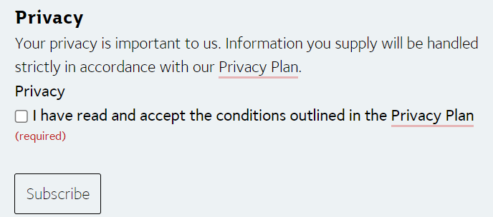

3.4 Store personal information securely and dispose when no longer required
Marketing and Communications will be able to support with systems and processes to enable direct marketing to be conducted efficiently, and critically, in a way that ensures that the personal information collected has appropriate security safeguards.
Once the direct marketing activities are completed and the personal information is no longer required, personal information should be deleted to eliminate the risk of data breaches associated with that information.

3.5 Use only for the purpose collected
Personal information collected to conduct direct marketing can only be used for that purpose. If other useful purposes are identified, they should not be pursued without a) obtaining further consent from the individuals, or b) obtaining advice from the Griffith Privacy Officer (privacyofficer@griffith.edu.au) about any exceptions that may apply that would enable that other use to take place.

3.6 Ensure persons can unsubscribe from future communications
Every message sent out electronically needs to have a working unsubscribe function so that recipients can opt-out of future messages. To be compliant, the unsubscribe option must:
- be clear and conspicuous in the message.
- provide clear instructions on how to unsubscribe.
- result in a person’s removal from future communications within 5 working days.
- be active for at least 30 days after sending the message.
You should also make clear what exactly it is that the person is unsubscribing from – e.g. the specific mailing list or newsletter, as opposed to all communications from Griffith University.
You cannot require payment of a fee or require a person to log-in to an account to unsubscribe.

4.0 Definitions
For the purposes of this policy and related policy documents, the following definitions apply:
Direct marketing means providing marketing and promotions direct to specific individuals using their personal information (e.g., their name, email, phone number).

5.0 Information
Title | Direct Marketing Procedures
Document number | 2023/0001225
Purpose | This procedure documents the necessary measures that must be undertaken when conducting direct marketing to ensure that the University complies with legislation including the Spam Act 2003 (Cth) and the Information Privacy Act 2009 (Qld).
Audience | Staff
Category | Operational
Subcategory | N/A
UN Sustainable Development Goals (SDGs) | This document aligns with Sustainable Development Goal/s:  4: Quality Education  16: Peace, Justice and Strong Institutions
Approval date | 8 December 2023
Effective date | 8 December 2023
Review date | 2026
Policy advisor | Director, Marketing & Communications
Approving authority | Vice President, Marketing and Communications

6.0 Related Policy Documents and Supporting Documents
Legislation | Information Privacy Act 2009 (Qld)  Spam Act 2003 (Cth)
Policy | Griffith University Privacy Plan
Procedures | N/A
Local Protocol | N/A
Forms | N/A

