Campus Access and Use

1.0 Purpose

2.0 Scope

3.0 Procedure
3.1 Campus Access | 3.2 Controlling Conduct on Campuses | 3.3 Hire of Facilities | 3.4 Security |
3.5 Car Parking | 3.6 General Matters

4.0 Definitions

5.0 Information

6.0 Related policy documents and supporting documents

1.0 Purpose
The purpose of this procedure is to operationalise the Facilities Management and Campus Access and Use Policy, which regulates access to University property and the conduct of anyone who enters that property. The Procedure also establishes the consequences of breaching conduct expectations.

2.0 Scope
This procedure applies across all University Campuses and to any person who accesses or uses these campuses.

3.0 Procedure
This Procedure should be read in conjunction with the Facilities and Campus Access and Use Policy and the Delegations Register.

3.1 Campus Access
Members of the University community, and members of the public who have a legitimate reason to be there may enter a Campus for those purposes unless the Campus has been declared closed.
A Campus may be declared closed by either the University Council or an Authorised Delegate to any persons for the period considered appropriate. Where a Campus has been declared closed, no-one may enter or remain on any Campus unless they have on their possession a Permit authorising them to enter or remain on that Campus.

3.2 Controlling Conduct on Campuses

3.2.1 Prohibited Activities
While on Campus, a person must not:
- engage in conduct that is unlawful or would be regarded by a reasonable person to be disruptive, destructive and/or unsafe,
- interfere with the lawful rights of others, or
- engage in speech or behaviour which contravenes the University’s parameters as specified in the Academic Freedom and Freedom of Speech Policy.

3.2.2 Disposing of Refuse
All waste must be properly disposed of in the bins provided.

3.2.3 Alcohol
Alcohol may only be consumed on campus when:
- the Campus or part thereof on which the alcohol is consumed are premises licensed pursuant to the Liquor Act 1992 (Qld), and
- that consumption of alcohol is authorised by the Vice Chancellor or an Authorised Delegate.

3.2.4 Drugs
Illicit substances or drugs must not be possessed, used, produced, supplied, received, sold or distributed on a Campus. No one on any campus may break any law prohibiting or regulating activities in relation to those substances.

3.2.5 Gambling
Any person wishing to undertake the following activities on campus:
- bet, offer to bet or accept a bet, or
- sell, purchase, offer for sale or offer to purchase any permit or coupon in a consultation, lucky envelope, tipping competition, bingo, raffle, sweep, race or lottery or similar games,
for the purpose of raising funds for a registered charity, raising funds for the University or as part of a University event must comply at all times with the Charitable and Non-Profit-Gaming Act 1999.
Private gambling/betting for personal financial gains, which is not authorised under an Act, is not permitted on Campus.

3.2.6 Weapons, Fireworks and Fire
No one may, on any Campus:
- possess, carry or discharge any offensive weapon (including a firearm),
- possess, set off or throw any fireworks,
- start or make any fire, except in fireplaces provided by the University for that purpose, or
- possess, throw or discharge any stone or missile or other dangerous substance, or threaten to do so
except in the course of their duty or in connection with their course of study or unless expressly authorised by Permit to do so.

3.2.7 Business and Trading
No trading, sale or goods, hire, lease or other commercial activities may take place on campus unless:
- written permission is obtained from an Authorised Delegate, or
- the trading takes place as part of an authorised business which is leasing or licensing premises from the University.

3.2.8 Use of Campus by University Clubs and other Affiliated Organisations
Members of University clubs and other affiliated organisations of the University may make use of those parts of Campuses designated for purposes such as games, sports or other activities, provided:
- they pay any fee requested by the University for such use and comply with any conditions of use imposed by the University,
- they comply with any direction given by an Authorised Delegate in relation to such use, including a direction to cease use (which may be given in relation to one instance of use or in relation to all or any number of instances),
- all events and activities involving the hire of University space is approved by an Authorised Delegate, and
- their use does not disturb or interfere with normal work, educational and related activities of the University.
The parts of Campuses designated under this section may be closed in accordance with section 3.1 above.

3.2.9 Performances and Events and Other Activities
The Head of Campus must approve the holding of any events, including but not limited to events such as:
- fetes, picnics, concerts, displays (including a display of film or television) or performances to be held on a Campus, or
- meetings, conferences, discussions, speeches, preaching or ceremonies to be held on a Campus (other than those activities undertaken by staff as part of normal University activities), or in any other way cause members of the public to congregate on a Campus.
To ensure all risks have been assessed and an appropriate management plan is in place and, if required a site licence is in place.
Non-educational activities involving the entertainment of public audiences will also require the appropriate copyright consents and licences to be obtained by the organiser prior to the event if music or films protected by copyright are to be played or otherwise communicated to a public audience.
Heads of Element are responsible for approving internal University activities and events in their respective Elements or organisational areas.

3.2.10 Care of Campuses and Buildings
No one may, unless it is part of their duties as an employee of the University:
- destroy, damage, injure or otherwise interfere with any Campus or part thereof,
- erect or construct, any habitation, building or structure on a Campus or use any part of a Campus as a habitation, or
- enter or occupy any habitation, building or structure on a Campus except in the usual pursuit of their work or studies, or as otherwise authorised by a lease or licence of premises granted by the University.

3.2.11 Animal Protection
A person must not disturb or shoot at or throw missiles at any animal on a Campus or attempt to capture or kill any animal unless permitted by an Authorised Delegate.
Animals are not permitted to be brought on Campuses unless:
- the animal in question is a certified guide, hearing and assistance dog and the person in question holds and is able to comply with the identification procedure (i.e. production of a valid identity card) of the Guide, Hearing and Assistance Dogs Act 2009,
- the presence of the animal is authorised by Permit,
- the animal is required for an employment, study or research purpose and is subject to the relevant Permit (excluding those animals acquired by the University for University activities), or
- the animal is required by a staff member or student to facilitate a consultation with a member of the University staff in connection with that animal. A permit must first be obtained for this purpose.
Griffith University supports assistance animals on campus and animals brought in specifically for organised events held for students and children in the Nathan Childcare Centres. Assistance animals are able to access the campus including teaching, recreational and dining areas. Exceptions to this include areas that would pose a risk to public safety, Operational Health and Safety Guidelines, or the animal(s). Students with assistance animals who require additional education support should negotiate support with a Senior Disability Adviser as soon as practicable.
The permit workflow is provided at Appendix 1.

3.3 Hire of Facilities

3.3.1 External and Internal Hiring
Where University spaces are not being used for core University activities, and particularly during non-teaching periods, spaces may be made available for hire to external and internal (i.e. University staff and students) clients. Hire of University spaces is reserved for activities which:
- are not incompatible with University strategic goals and values,
- are lawful and compliant with University policy,
- do not constitute a risk to the safety of members of the University community or University property,
- are unlikely to interrupt the core activities of the University or otherwise create unwarranted disturbance to the amenity of the Campus.

3.3.2 Fees, Charges and Conditions of Hire
The hire of University spaces to external organisations will generally incur a venue hire fee. Commercial rates will apply for all external bookings other than:
- for external business entities that are registered as a charity or not for profit and will not be charging an admission/participation fee or receiving any financial benefit from the event, or
- for the purpose of promoting Griffith University to third parties.
The hire of University spaces to internal users will generally not incur a venue hire fee. The following factors will be taken into account when determining the hire charge for an internal booking:
- Activities for which admission or participation fees are charged may be liable for commercial rates and any associated direct costs.
- Where the application is made, by a University community member or organisation, on behalf of a commercial operator or non-university business, Commercial rates apply.
University Student clubs, associations, societies, and affiliated organisations which are approved through appropriate channels may be charged a hire fee to hire University spaces.
Regardless of whether or not a hire fee is charged, any direct costs associated with the room hire will be charged to the user. These costs may include items such as security, cleaning, room set up, after hours air-conditioning etc. Venue hire charges are approved by the Director, Campus Life and updated on the University’s venue hire information page. Potential hirers should consult the schedule of venue fees for the list of charges, including late change and cancellation fees. All venue hire is subject to the terms and conditions of the University’s venue hire agreement.

3.3.3 Declining Bookings
The University reserves the right to decline or cancel any booking request at any time without providing a reason. In particular, but without limitation, the University may decline to hire facilities for speakers or events in accordance with the principles of the Academic Freedom and Freedom of Speech Policy and compliance with the Human Rights Act 2019, where the proposed speech:
- constitutes hate speech or is in any other way unlawful, including through the encouragement of law-breaking,
- is detrimental to the University’s responsibilities for the wellbeing, health, and safety of all members of the University community, or
- involves the advancement of theories or propositions which purport to be based on scholarship or research, but which fall below scholarly standards to such an extent as to be detrimental to the University’s character as an institution of higher learning
- decisions to deny an internal or external party access to campus based on the event content are to be determined by the Head of Campus.

3.4 Security
The security of the University community, visitors to campus, and campus facilities and infrastructure, are critical concerns. To this end, the University uses the services of Authorised Security Officers to ensure the safety and security of all Campuses.
Authorised security officers:
- regulate the access and behaviour of persons on University premises,
- make enquiries and take reasonable action to regulate the access and behaviour of students, staff, contractors, and visitors while they are on University premises in order to maintain a safe and secure environment,
- exercise the same powers of arrest as those available to any member of the public under the Criminal Code Act 1899 (Qld),
- prominently display their issued identity card or can produce it on demand at all times,
- do not have a general power to search a person’s body or property without that person’s consent, except:
  - where the search is a condition of entry to a premises or event and appropriate signage is clearly displayed at the entrance notifying people that their persons or their bags may be the subject of a search; or
  - a screening device is used as a condition of entry and the device indicates that the person may be carrying a prohibited or hazardous item, or
  - it may be necessary to confiscate any weapons or items which may be used to cause harm to the person or to others.
All non-emergency security incidents which occur on Campus must be reported to security personnel.

3.5 Car Parking
Parking is at the risk of the vehicle’s operator. The University accepts no responsibility whatsoever for any loss or damage to a vehicle while it is within University premises, even if caused by the negligence of the University, its officers, or agents.
A person to whom a parking permit is issued is responsible for any breach of the rules or any damage caused by the vehicle which bears the parking permit – even if another person drove or parked the vehicle and caused a breach of the rules or the damage.
Parking facilities for students, staff, contractors, and visitors are provided in accordance with the car parking rules.

3.6 General Matters

3.6.1 Consequences of Breach
Any breach of this Procedure will be dealt with as follows:
- For students, in accordance with the Student Conduct, Safety and Wellbeing Policy,
- For staff members, in accordance with the relevant disciplinary provisions in their terms of employment,
- For visitors or others, as permitted by law.

3.6.2 Removing Property, wildlife or native flora
Except in the performance of their duties as an employee of the University, or with the consent of an Authorised Delegate, a person must not remove from a Campus or move from one part of a Campus to another, any fixed or movable University property, wildlife or native flora.

3.6.3 Interfering with University Activities, Campus Works, and Services
No one may:
- act in a manner intended to interfere with the normal activities of the University, or with carrying out any works on a Campus,
- perform any act declared by the Vice Chancellor, an Authorised Delegate, University policy or procedure to be prohibited where this prohibition has been communicated to them.
No one, while physically present on any campus, may obstruct, hinder, or harass:
- any Authorised Person or employee of the University in the discharge of their duties, or
- any person in the exercise and enjoyment of any lawful activity duly authorised under this Procedure.

3.6.4 Direction to Leave Campus
An Authorised Person may direct any person to leave a Campus if there are reasonable grounds to suspect that the person has contravened Schedule 1, Part 3, section 12 of the Griffith University Act (Conduct causing a public nuisance) or other law which allows such a direction.

3.6.5 Maintain Orderly Conduct on Campus
An Authorised Person or Authorised Delegate may give directions and make requests in the name of the University as may be required to maintain order within the University and to maintain orderly conduct by members of staff, students and visitors. They may also require any person on a Campus to do any or all of the following:
- leave the Campus or part of a Campus immediately,
- cease conducting any activity upon the Campus immediately,
- produce for immediate inspection any Permit,
- provide their full name and address.
If the Authorised Delegate reasonably believes that the presence of any person is detrimental to the welfare of the University community, the Authorised Delegate may issue that person with a written notice prohibiting that person from entering or remaining on a Campus.
A person served with a notice under this section may make a written submission to the Chief Operating Officer setting out the reasons why that notice should be rescinded.
The Vice Chancellor must decide either to affirm or rescind a notice within 14 days of receipt of a written submission made under this section.
Any person served with a notice issued under this section must not enter or remain or attempt to enter or remain on a Campus specified in the notice unless and until the Chief Operating Officer rescinds an appealed notice or the notice is otherwise rescinded by the Authorised Person or Authorised Delegate.

3.6.6 Emergency Services
Emergency services are permitted to enter University premises:
- in response to a call for assistance from students, staff, or a member of the public,
- in an emergency situation,
- to conduct routine patrols,
- as part of their commitment to community safety.
All students, staff and members of the public should notify security of any emergencies where police or other emergency services have been called.
Authorised security officers coordinate and expedite emergency services attendance at the emergency site and ensure police are notified of any criminal incidents on Campus, including those relating to the loss or damage of personal property.

3.6.7 Delivering Permits
Any Permit issued pursuant to this Procedure, must be in writing and will be regarded as having been duly given and received if it is:
- delivered in person to whom it is addressed – on that day,
- sent through the post in a pre-paid envelope with the address provided by the applicant – on the next business day in which the post would ordinarily be delivered,
- emailed to the address provided by the applicant – when the email becomes capable of being retrieved by the addressee, provided no failure to transmit record was received by the sender.

4.0 Definitions
For the purposes of this policy and related policy documents, the following definitions apply:
Authorised Delegate means the University officer formally authorised to carry out a delegation or act on behalf of the University as specified in the Facilities Management and Campus Access and Use Policy and/or University’s Delegation Register.
Authorised Person has the same meaning as in Schedule 1 of the Griffith University Act.
Campus includes any land or part thereof which for the time being is the property of the University or in its possession or under its control, together with any structure of any kind whether permanent or temporary on that land.
Permit means a current valid written authorisation to perform certain acts otherwise prohibited by this Procedure.
Restrictions mean Reasonable, Academic, Freedom Restrictions, Reasonable Free Speech Restrictions or Reasonable Use Restrictions as defined in the Academic Freedom and Freedom of Speech Policy.

For advice and support contact policy@griffith.edu.au for Governance and Operational policy documents.

Appendix 1
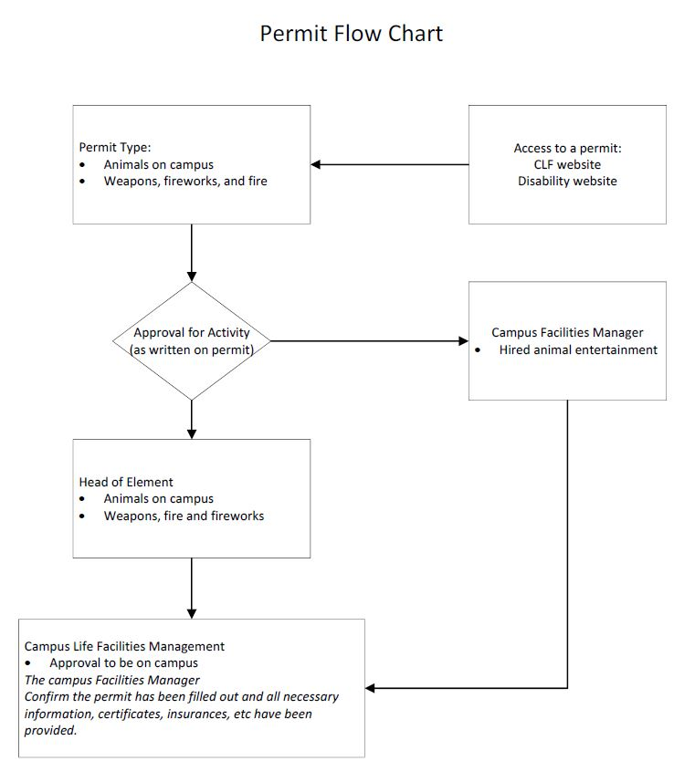

Information
Title | Campus Access and Use Procedure
Document number | 2023/0001161
Purpose | The purpose of this procedure is to regulate access to University land, the conduct of anyone who enters that land and to establish the consequences for breach.
Select an Audience | Staff, students, public
Category | Operational
Sub-category | Campuses and Facilities
UN Sustainable Development Goals (SDGs) | This document aligns with Sustainable Development Goal/s:  11: Sustainable Cities and Communities
Approval date | August 2021
Effective date | August 2021
Review date | 2025
Policy advisor | Associate Director, Facilities Management
Approving authority | Director, Campus Life

6.0 Related Policy Documents and Supporting Documents
Legislation | Charitable and Non-Profit-Gaming Act 1999  Criminal Code Act 1899 (Qld)  Griffith University Act 1998  Guide, Hearing and Assistance Dogs Act 2009  Human Rights Act 2019  Liquor Act 1992 (Qld)  Queensland Criminal Code 1899
Policy | Academic Freedom and Freedom of Speech Policy  Code of Conduct  Facilities Management and Campus Access and Use Policy  Student Conduct, Safety and Wellbeing Policy
Procedure | Space Management Procedure  Student General Conduct Procedure  Car Parking Rules
Local Protocol | N/A
Form | Permit – Animals on Campus  Permit – Hold, Carry, Work with a Weapon, Fireworks, Fire

