Academic Employee Career
Development
1.0 Purpose
2.0 Scope
3.0 Procedure | 3.1 Overview | 3.2 Timing | 3.3 Academic Employee Career Development cycle | 3.4 Mid-cycle reviews and discussions | 3.5 Annual review discussion | 3.6 If an academic employee does not submit their AECD Plan | 3.7 Career development evidence | 3.8 Completing the process
4.0 Definitions
5.0 Information
6.0 Related Policy Documents and Supporting Documents

Purpose
This procedure provides direction for the Academic Employee Career Development (AECD) process.
The primary objectives of the Academic Employee Career Development review are to:
- support the continued high performance of employees and plan for career success and professional development in light of the advancement of the University’s strategic objectives
- enable employees and academic supervisors to engage in frequent and ongoing conversations to provide feedback on progress and, if required, establish new or revised objectives during the review cycle
- review progress towards previously established objectives and outcomes and set specific annual objectives and outcomes in the context of the University’s strategic objectives
- reach agreement on proposed professional development activities or resources that will support academic career success
- review and assign an appropriate work allocation profile and
- review and approve leave plans for the following calendar year.

Scope
This procedure applies to all academic employees employed by the University on a continuing or fixed term basis, including part-time appointments of 12 months or more.
Academic manager positions (such as Heads of School/Department, Deans, and Directors of University Centres/Institutes) are covered by the Performance Management of Academic Managers Policy and Procedures.
For academic employees on probationary appointments, these procedures should be read in conjunction with the Academic Employee Probation Procedure.
Management of unsatisfactory performance or misconduct is separate and different to the AECD process. Nothing in these procedures restricts or prohibits the University from taking action to address performance and/or conduct issues in accordance with the Academic Staff Enterprise Agreement.

Procedure

Overview
- The University is committed to enabling employees to reach their full potential by supporting employees and supervisors to engage in regular and meaningful performance conversations and developing fit-for-purpose leadership and development programs that build the necessary skills and capabilities required now and into the future.
- Each employee’s career development plan should be cascaded in alignment with the University strategic plans, Group strategic and operational plans and School/Department/Research Centre work area goals.
- Established career goals and annual objectives are to be consistent with:
- the Position Classification Standards (PCSS) for Academic Staff and/or Minimum Standards for Academic Levels – Research Academic Staff (MSALs)
- academic expectations set by the Group and relevant conditions of appointment
- the academic employee’s work allocation.

Timing
- The AECD process operates on a cycle that allows for long-term goal setting, with progress towards these goals broken down into annual objectives with measurable outcomes for each objective. The annual cycle includes the identification of professional development activities.
- This process is intended to be dynamic and interactive and includes provision for mid-cycle and annual adjustments based on changing priorities. Its application builds on the University’s core values and commitments and behaviours as outlined in the Code of Conduct.

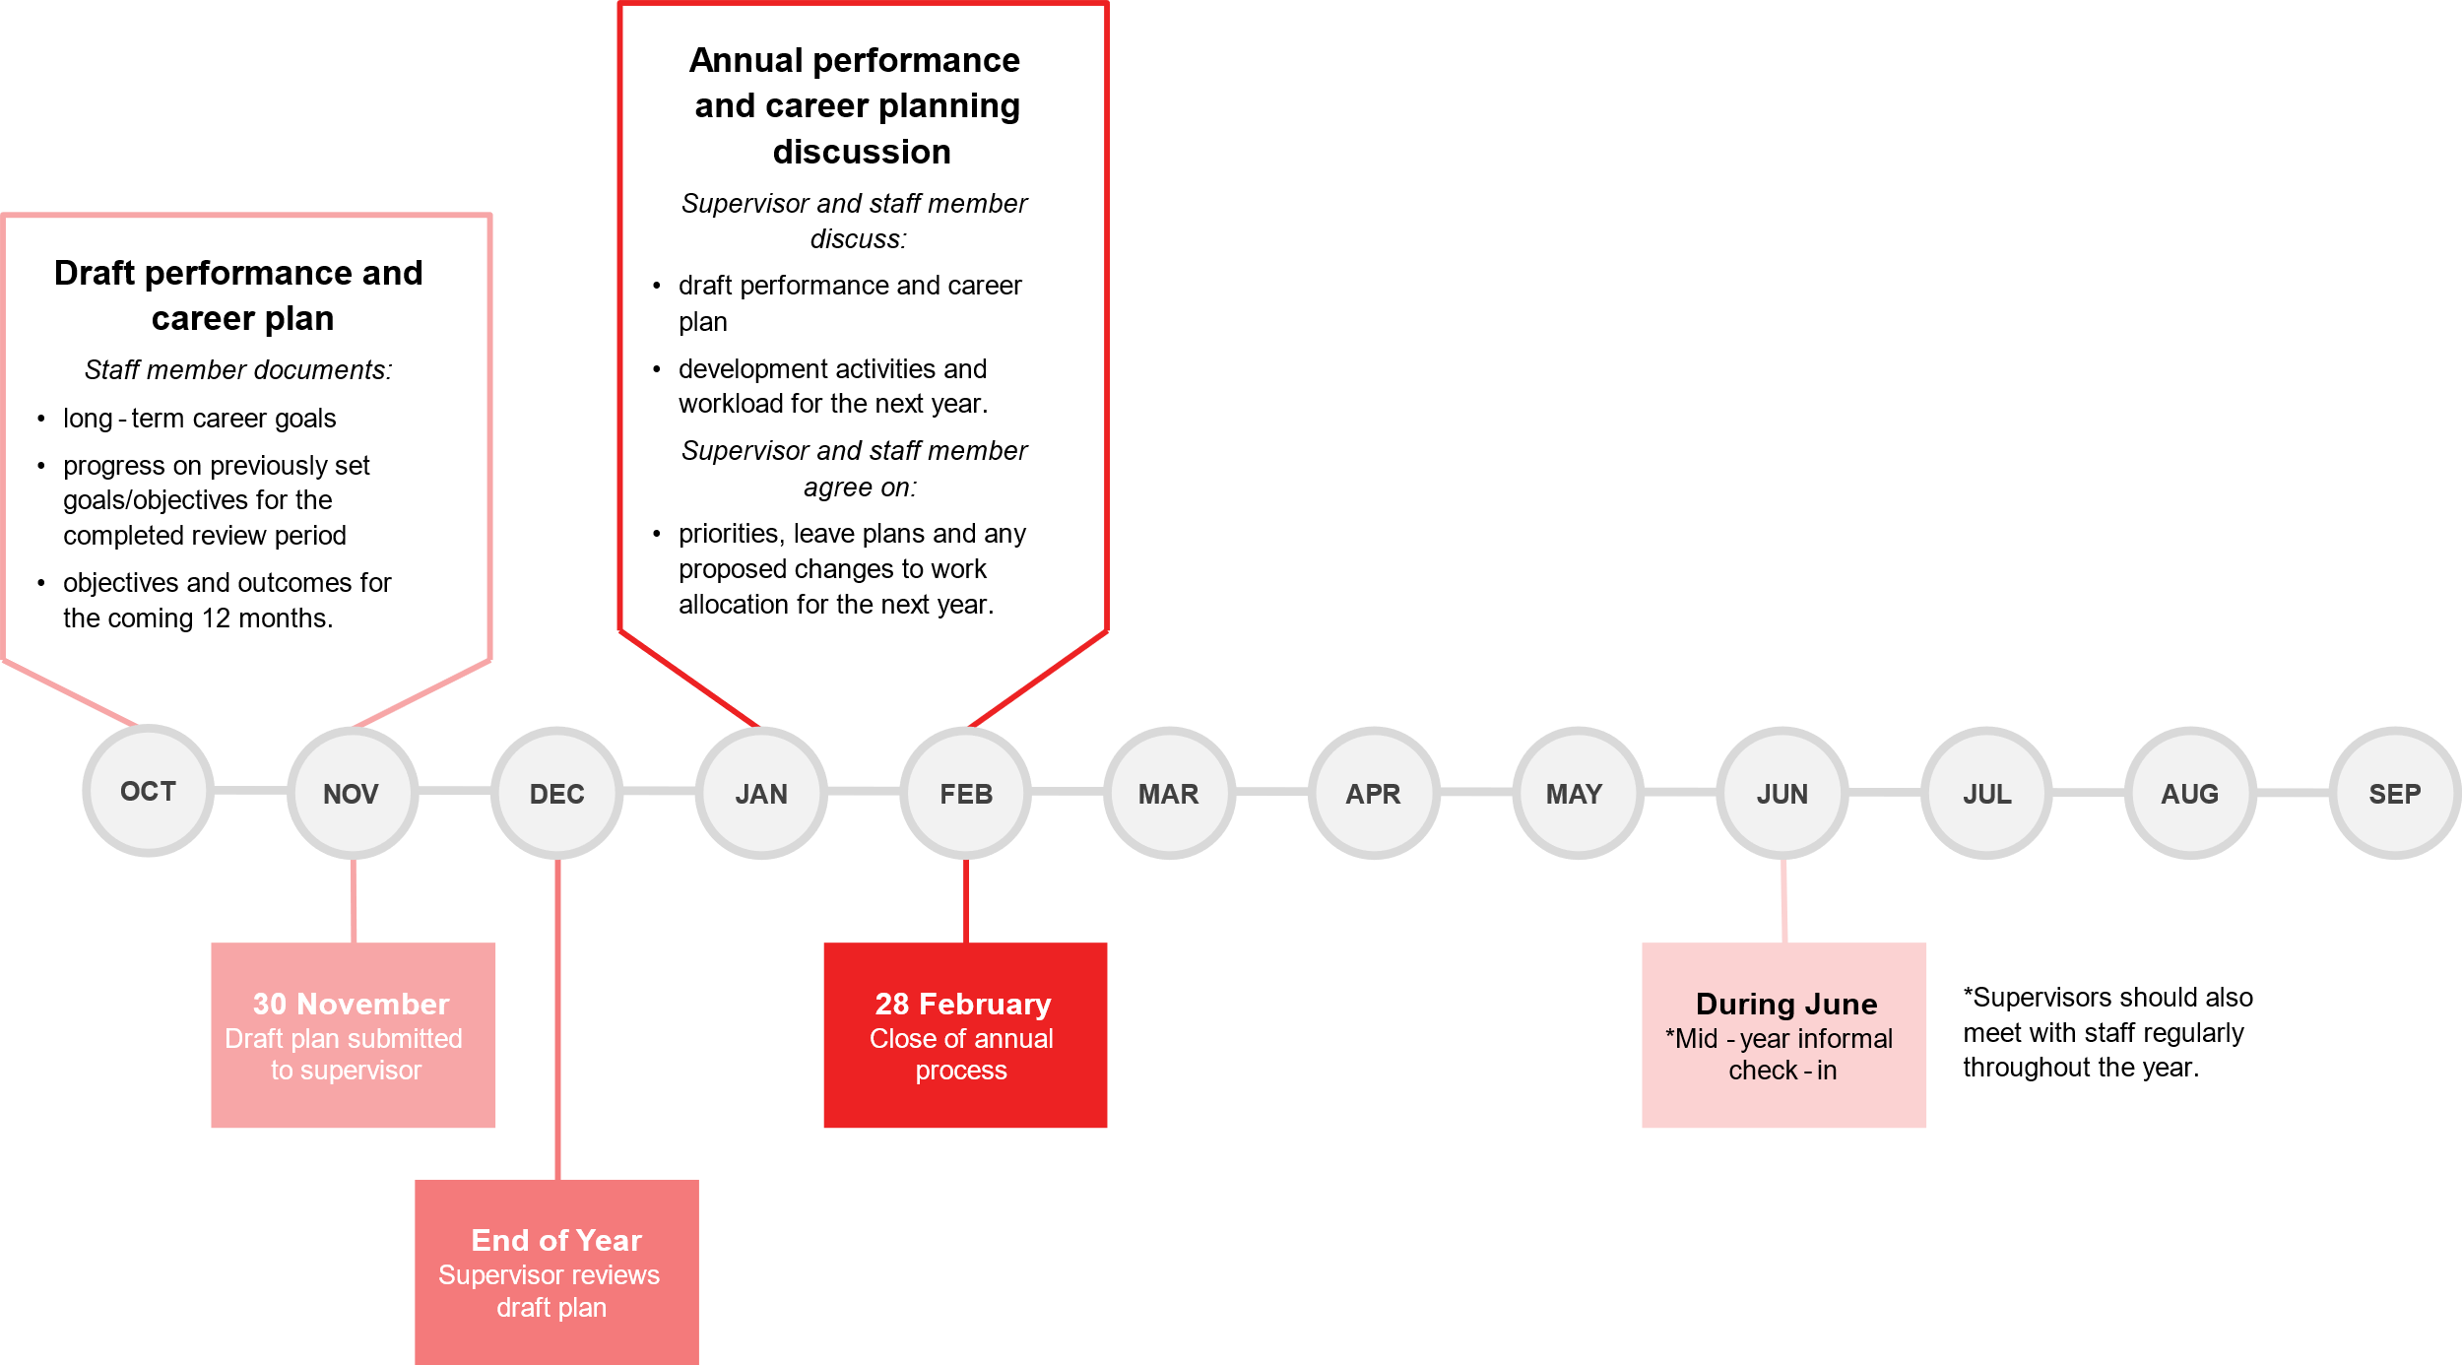
Academic Employee Career Development cycle

The Group Pro Vice Chancellor, may, in consideration of special circumstances for an employee at the level of Professor, recommend to the Provost for approval of an alternate performance review process and deferral of the requirement for submission of an AECD Plan.

Mid-cycle reviews and discussions
- At any time during the year, the supervisor or the employee may request a meeting to discuss progress against the performance and career plan, career goals, and emerging professional development needs.
- At a minimum, it is expected that academic supervisors should meet with employees at least once per year in addition to the annual review meeting (the mid-year check-in) to review progress, establish new or revise existing goals and recommend development activities where required. Formal documents are not required for this meeting unless requested by the supervisor.

Annual review discussion
- An annual review of each employee’s career and performance plan will be undertaken. The review will inform the amendment of the plan for the new year.
- The employee and academic supervisor will complete the plan ensuring that the objectives and outcomes for the forthcoming review period and proposed professional development activities and/or resources will support the academic employee for career success.
- The academic supervisor will consult with the relevant Institute/Research Centre Director, Dean (Research) or Dean (Learning and Teaching) where applicable, to obtain advice and/or support for the proposed research/scholarship or learning and teaching objectives and outcomes.
- Where the academic Supervisor is not the Head of School/Department or University Research Centre/Institute, the original copy of the employee’s AECD Plan is to be provided to the Head for review and approval of the work allocation profile and proposed leave application(s) for the following year.
- An original copy of the employee’s AECD plan will be sent for filing on the staff member’s personnel file and the staff member should retain an electronic copy of the completed plan for reference. Where concerns about performance arise, they should be raised as soon as practicable after they are identified, and steps made to address the issues as required in the Academic Staff Enterprise Agreement.
NB: The management of unsatisfactory performance or misconduct is separate and different to the Academic Staff Career Development process. If the overall performance of the employee is identified as unsatisfactory, it will become necessary to cease the AECD process as outlined in this procedure and commence the unsatisfactory performance process prescribed in the Academic Staff Enterprise Agreement.
Tasks within the Annual Review process are detailed in the table below.
ROLE | RESPONSIBILITIES
EMPLOYEE | - Prepare their AECD Plan in accordance with these procedures, including providing the supervisor with the necessary information at least four weeks prior to the scheduled meeting.  - Reflect on their career goals for the coming year and longer term and ensure alignment of their annual objectives with those of the School/Department/Centre and Group and the University’s strategic plan.  - Participate positively in the annual review meeting and attend any briefing sessions related to the process.  - Work with the supervisor to finalise the AECD Plan and undertake any revisions as required.  - Complete any follow-up actions required to address any areas identified as requiring improvement.  - Encourage the giving and receiving of regular and constructive feedback with the supervisor.
SUPERVISOR | - Schedule the annual meeting and prepare for and conduct the meeting in accordance with the procedures.  - Undertake the necessary supervisor training, where relevant, related to career success.  - Provide ongoing, regular and constructive feedback, advising employees on available development options and relevant career support.  - Assist the employee to finalise their AECD Plan ensuring alignment to the School/Department/Centre/Institute, Group and University goals.  - Review current leave arrangements and consider and recommend/approve (within delegation) leave plans for the following calendar year.  - Monitor staff workloads in accordance with the Teaching Allocation Guidelines.  - Together with the employee complete the AECD Plan and report on the outcomes of the year-end meeting for submission to the Head of School/Dean (Academic), when the supervisor considers that the employee’s performance requires improvement in any area of academic emphasis.  - Take any follow-up action on matters agreed at the meeting including ensuring the arrangement of training and development.  - Provide overall comments on the employee’s performance, noting any equity/diversity or personal circumstances that may have impacted on the employee’s ability to achieve the established objectives or outcomes for the current period.  - NB: Where the supervisor is not the Head of School/Department or Director, University Research Centre/Institute any training and development proposals are to be confirmed by the Head of School/ Department/ Centre/ Institute.
THE HEAD OF SCHOOL/DEPARTMENT OR DIRECTOR, RESEARCH CENTRE/INSTITUTE | - Provide clear direction to staff and supervisors on expected achievements for the School/Department/Centre/Institute, including communicating the applicable Group-specific requirements.  - With advice from the relevant portfolio Deans, provide guidance for improving the effectiveness of teaching and learning, research and research training, scholarship, engagement and leadership outcomes.  - Ensure that supervisors have attended the necessary training.  - Support employees for high performance.

If an academic employee does not submit their AECD Plan
An employee who fails to complete their plan will be instructed in writing by their academic supervisor to submit the document by a specified date and informed that failure to do so may result in disciplinary action in accordance with the relevant provisions of the Academic Staff Enterprise Agreement.

Career development evidence
- An academic dashboard supporting the employee’s contributions across their academic career (learning and teaching, research, scholarship, service and engagement) is collated in conjunction with the AECD Plan.
- The dashboard is used to provide additional evidence of the employee’s performance against the agreed long-term goals, objectives and outcomes. It includes:
- SET/SEC data that is used as a basis for discussions around learning and teaching quality and innovation and/or required development
- other evidence of teaching evaluation, including if applicable, peer reviews
- a copy of the academic employee’s Researcher Profile accessed via the Research Dashboard
- evidence of industry or community engagement, where necessary
- academic CV (may be requested by the supervisor, especially in cases where a new supervisory arrangement commences).

Completing the process
At the conclusion of the annual meeting, the employee and supervisor are required to finalise the documentation/process through the relevant online system.

Definitions
Academic Supervisor is normally the Head of School/Department or Research/Institute Centre Director. However, another academic employee classified at Level D or above may be appointed by the Dean (Academic) as supervisor of one or more employees or groups of staff.
The employee has a right to request a different supervisor. Staff must apply, in writing, stating the reason for the request to the Dean (Academic).

Information
Title | Academic Employee Career Development
Document number | 2024/0001107
Purpose | This procedure provides direction for the Academic Employee Career Development (AECD) process.
Audience | Staff
Category | Operational
Subcategory | Staff
UN Sustainable Development Goals (SDGs) | This document aligns with Sustainable Development Goal:  8: Decent Work and Economic Growth
Approval date | September 2024
Effective date | September 2024
Review date | 2026
Policy advisor | Director, Human Resources
Approving authority | Provost

Related Policy Documents and Supporting Documents
Legislation | Academic Staff Enterprise Agreement 2023-2025
Policy | Academic Studies Program Policy  Code of Conduct  Delegations Policy  Performance Management of Academic Managers Policy and Procedures  Promotion of Academic Employees Policy  Student Experience of Courses (SEC) and Teaching (SET)
Procedures | Academic Employee Probation Procedure  Academic Studies Program Procedures  Delegations Procedure  Promotion of Academic Employees Procedure
Local Protocol | Academic Employee Career Development website
Forms | N/A

